Yamaha XG Software Synthesizer WDM Driver for Windows XP and 2000 installation guide.

This is the last Yamaha XG Syx50 Software Synthesizer Yamaha created, it is a trial that expires after 60 days. It thusso is trial ware.

0 Create a Windows machine with a Windows XP installation. You can do this with Virtual Box or VMWare inside your current Windows 7/10 or on a real working Windows XP legacy machine. Before installing this driver know that after 60 days it expires. If you create a snapshot of the Virtual Machine you can repeat reinstalling over and over again every 59 days by restoring the snapshot.

1 Download this file to your desktop inside Windows XP desktop. You can configure SHARED FOLDERS with Virtual Box or VMWare if you want to do it the easy way.

YAMAHA-XG-WDM-SoftSynthesizer-for-Windows-XP2k-Ver 5.13.2600.31.zip
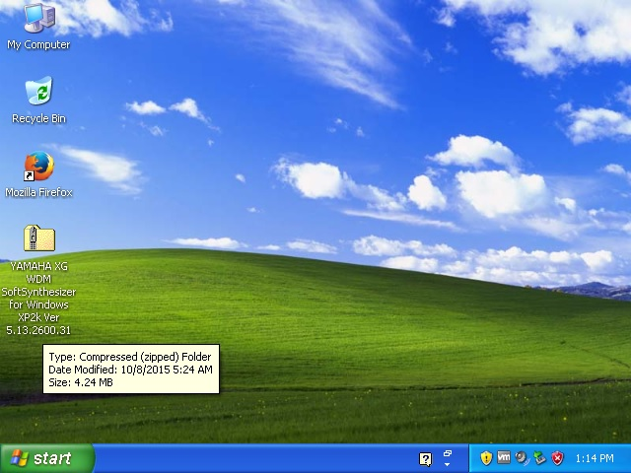

2 Open the zip file with double click or either single click whatever you configured. A folder will popup with the WDM Driver Files. Right click with your mouse in an empty white area of this folder and choose: ' EXTRACT ALL '.

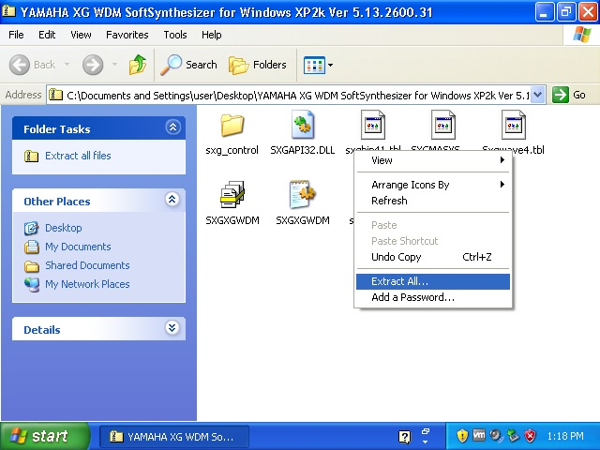

3 Follow the button ' NEXT ' as seen in the picture below. You will be asked for a place to extract but just press NEXT if it asks you to do so.

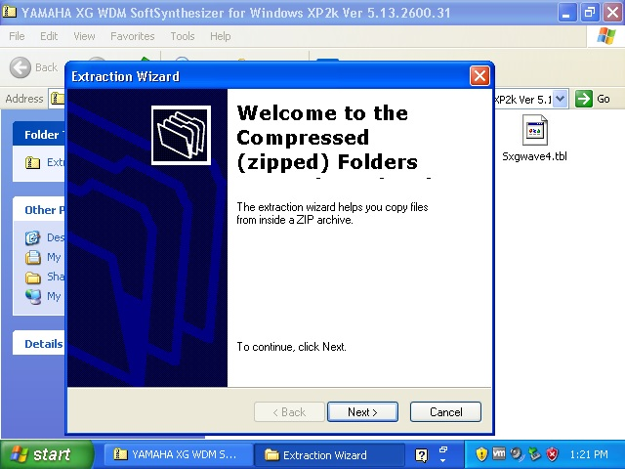

4 Finally you see this image. It is important that you are sure where you have extracted the files. So 'Show Extracted Files' must be enabled. Then click Finish.

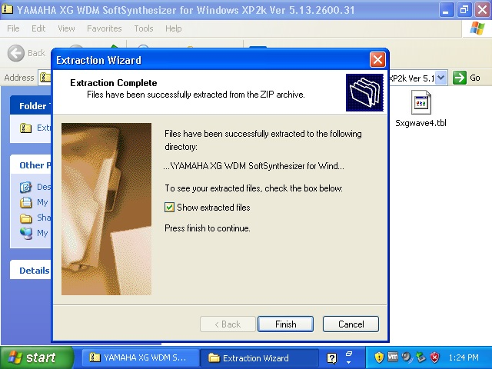

See next page

5 As you can see the files have been extracted to the Desktop by default. Now look carefully below, enter the Folder named 'SXG_CONTROL' by double clicking or single click, it contains an important file.

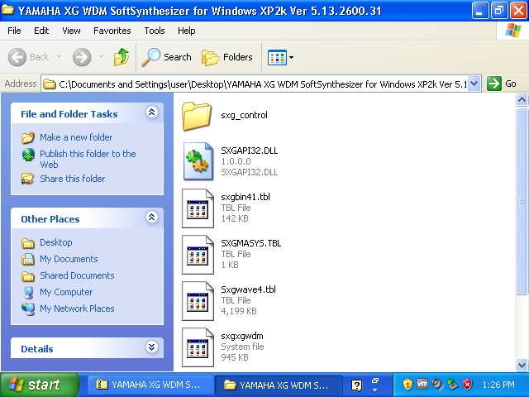

6 Inside the Folder 'SXG_CONTROL' you will find a file named 'sxgmacpl'. Right click that file and select 'COPY'. This file must be copied to the 'C:\Windows\System32' directory Folder.

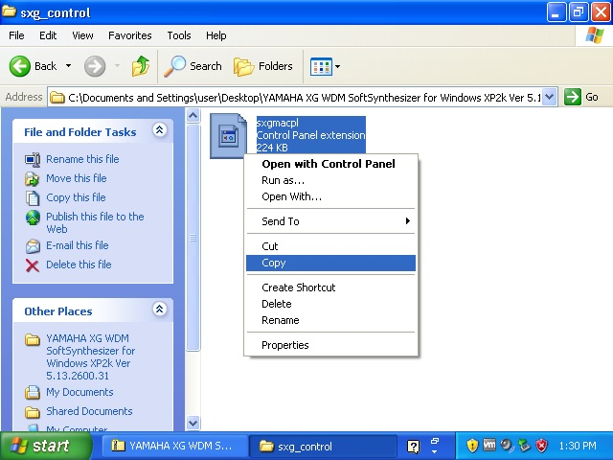

See next page
7 You might see a warning to not enter this directory ignore. Click 'Show the contents of this folder'.

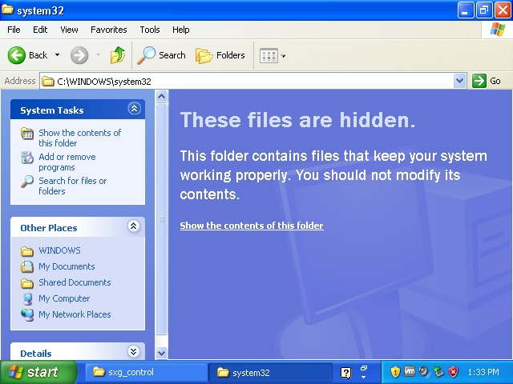

8 And finally right click with your mouse inside an empty white area of the 'C:\Windows\System32' folder. And paste the file you before selected to copy. If you do not do this then you will not be able to configure the Yamaha XG Software Synthesizer to 44.1 kHz and 64 Polyphony. After this you can close this 'system32' Folder Window.

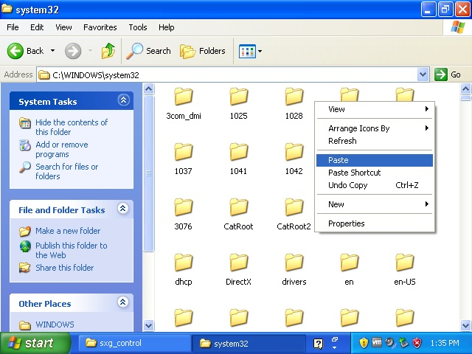

See next page

9 Close all Windows on your Windows desktop. Goto your 'Start' menu and select 'Control Panel'. This will open a new window where you can add hardware.
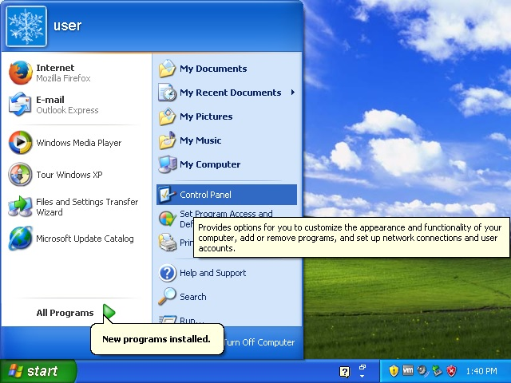

10 Be certain to click 'Switch to Classic View'. As this will show you all Control Panel Items.
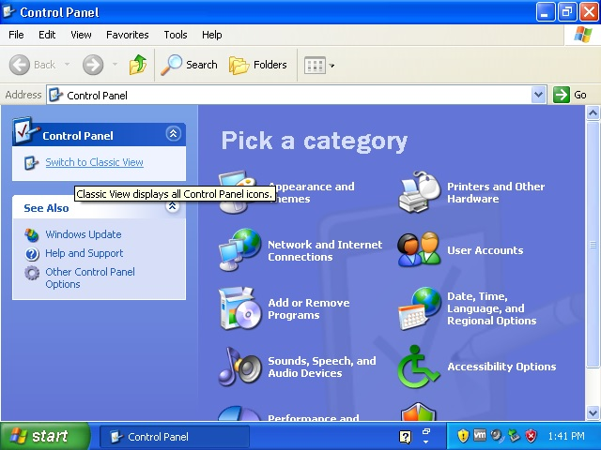

See next page

11 Look for this item inside the Control Panel Window
'Add Hardware'
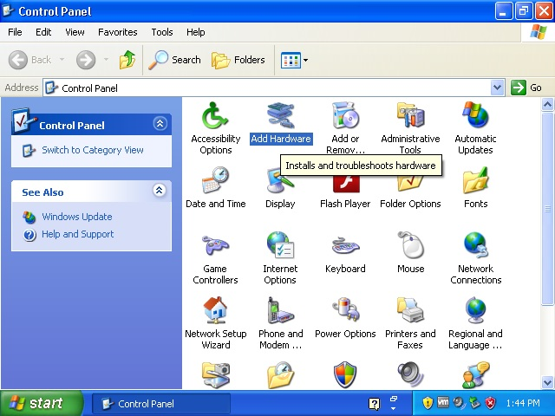

12 Just click 'Next'.
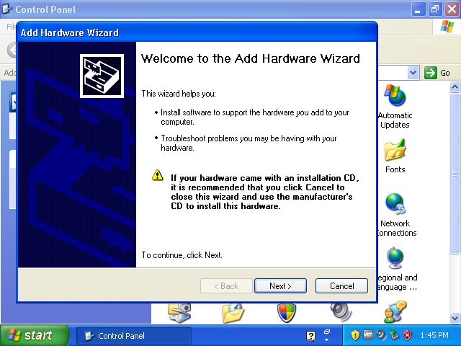

See next page

13 Now select 'Yes, I have already connected the hardware', and click 'Next'.
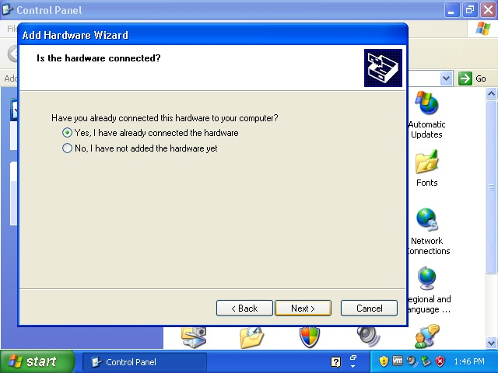

14 Scrol down in the list until you can select 'Add a new hardware device'.
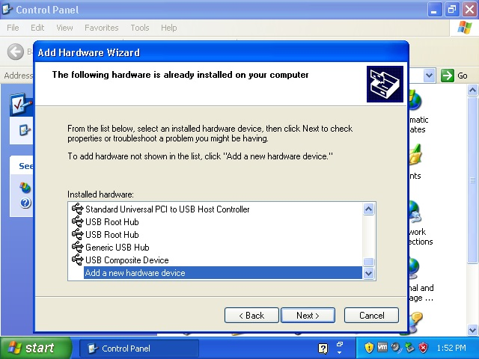

See next page

15 Select 'Install the hardware that I manually select from a list (Advanced)' and click 'Next'
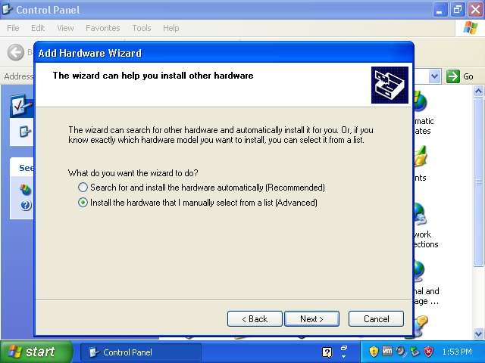

16 Select 'Show All Devices' and click 'Next'. This will take a minute or 2. Especially inside a Virtual Machine it might look for a while your Virtual installation does not respond. This is normal.
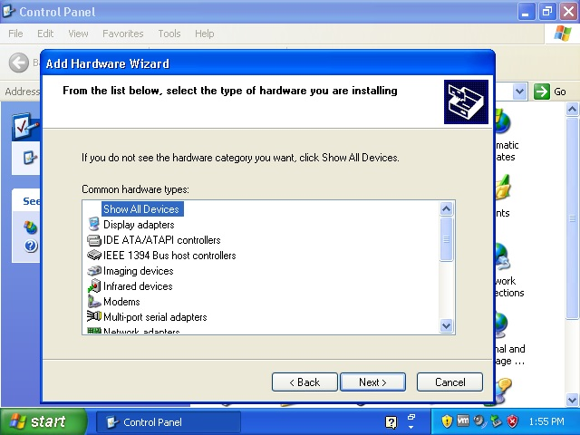

See next page

17 And now we are ready to select the extracted Folder you have extracted at your desktop. So click 'Have Disk'.
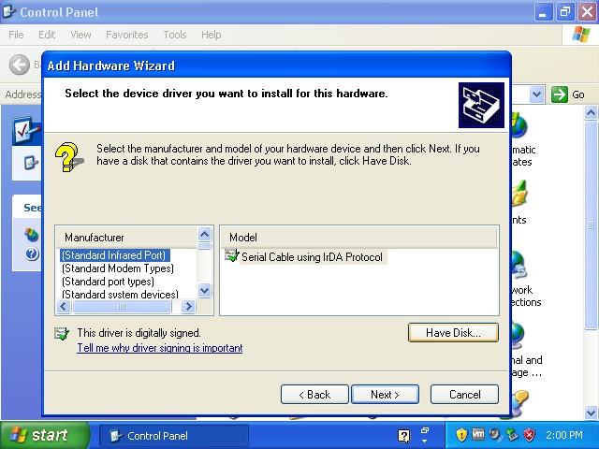

18 Enter the Folder by clicking it as shown below in the image.
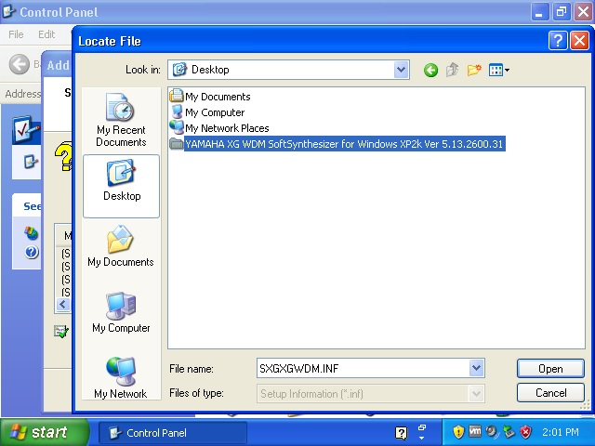

See next page

19 Select the 'SXGWDM.inf' file and click 'Open'
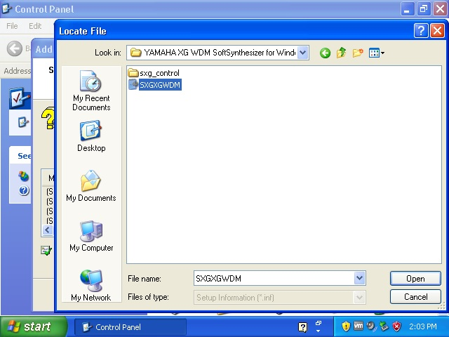

20 And we are almost there, select the YAMAHA XG WDM SoftSynthesizer. Click 'Next'. You will be asked a few times to press 'Next' that is all.
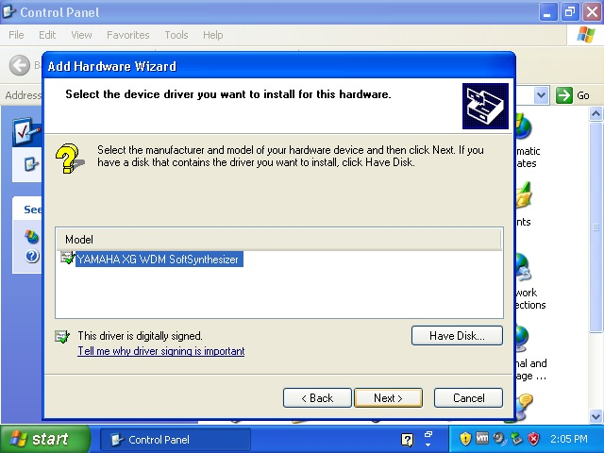

See next page

21 You will now see this image as seen below. Click 'Finish'.
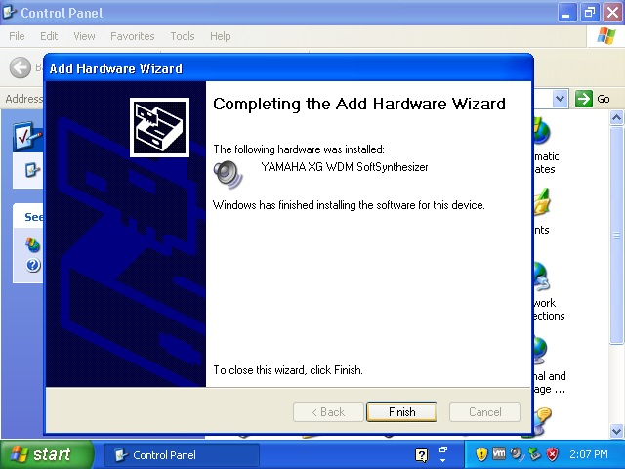

22, Shutdown your Windows machine, boot it up again. Or restart.
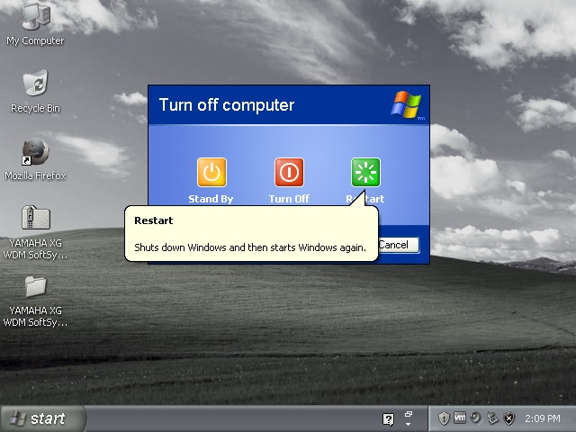

See next page

23 The Yamaha Synthesizer is now installed, however you want to have 44.1 kHz and more Polyphony. Goto start menu and select 'Control Panel'.

24 As you can see the Yamaha Synthesizer is not visible yet in the 'Control Panel'.

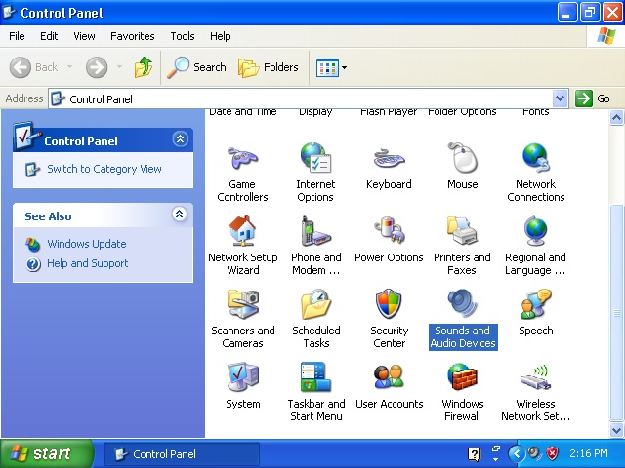

What we need to do is to repeat Step 5, step 6 and step 7 in this Installation Guide. And then reboot the system again.

See next page
Step 5, Now look carefully below, enter the Folder named 'SXG_CONTROL' by double clicking or single click, it contains an important file.

Step 6, Inside the Folder 'SXG_CONTROL' you will find a file named 'sxgmacpl'. Right click that file and select 'COPY'. This file must be copied to the 'C:\Windows\System32' directory Folder.

See next page

Step 7 and 8, And finally right click with your mouse inside an empty white area of the 'C:\Windows\System32' folder. And paste the file you before selected to copy. If you do not do this then you will not be able to configure the Yamaha XG Software Synthesizer to 44.1 kHz and 64 Polyphony. After this you can close this 'system32' Folder Window.

Repeat step 22, Shutdown your Windows machine, boot it up again. Or restart.

See next page

25 As you can see below, from the Start Menu → Control Panel → Scrolling down shows you the 'XG Synth Driver' inside the 'Control Panel'. Open it by double click or single click whatever.
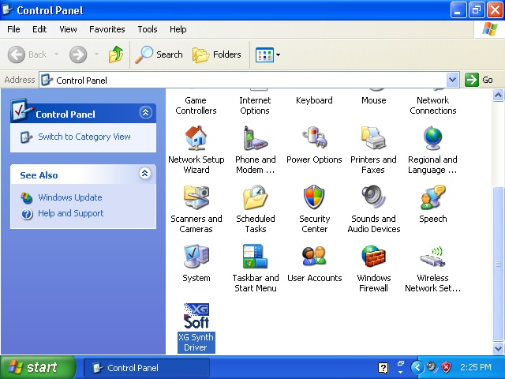

26 Configure it at 44.1 kHz and what you like. We are now ready to go!
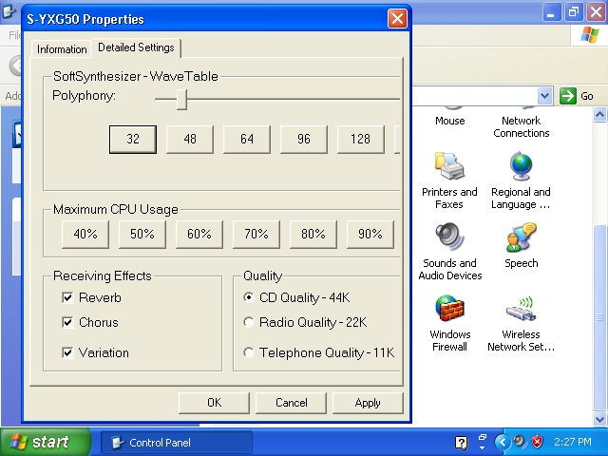

27 Enjoy Yamaha XG Midi Files.

28 If you use a Virtual Machine, do not record the audio inside the Virtual Machine. Only use the Virtual Machine for Audio Playback with this Virtual Yamaha XG Synthesizer. The only difference between the SYX50 and SYX100 is that SYX100 is for Windows 9x and not Windows XP. You can record the audio at your host e.g. Windows 7/10 with a program named Audacity. If you try to record audio inside a Virtual Machine you will fail. It is only suitable for playback. And yes it works.

Regards, DJ ALIAS 1984 (DJ Wuppie 1984)

